Functional Index Report
The indices shown below represent an analysis of your blood test results. These results have been converted into your individual Functional Indices Report based on our latest research. This report gives me an indication of the level of dysfunction that exists in the various physiological systems in your body from the digestion of the food you eat to the health of your liver and the strength of your immune system – which are all key factors in maintaining optimal health. We can use this information to put together a unique treatment plan designed to bring your body back into a state of functional health, wellness and energy.
Score Guide:
90% - 100% - Dysfunction Highly Likely.
75% - 90% - Dysfunction Likely.
50% - 75% - Dysfunction Possible.
40% - 50% - Poor Function.
< 40% - Dysfunction Not Likely. Further Testing May Be Needed.
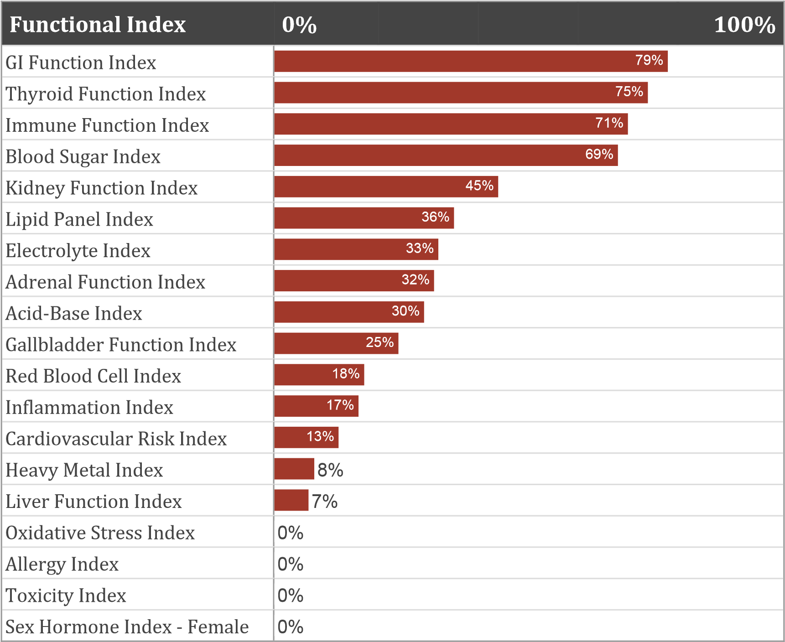
GI Function Index
The GI Function Index reflects the degree of function in your gastrointestinal (GI) system. The gastrointestinal system is responsible for the digestion and breakdown of macro nutrients (proteins, fats and carbohydrates) into small particles so they can be easily absorbed and utilized. The GI systems is also responsible for the excretion and elimination of waste from the body. Your body’s nutritional status is directly affected by your ability to digest macronutrients and also to absorb key vitamins, minerals, amino acids, essential fatty acids and accessory nutrients such as bioflavonoids, CoQ10, etc. Factors affecting the GI function include inadequate chewing, eating when stressed or in a hurry, lack of appropriate stomach acid (a condition called hypochlorhydria), inflammation in the stomach lining (a condition called gastritis), a decrease in digestive enzymes (a condition called pancreatic insufficiency), an overgrowth of non-beneficial bacteria in your digestive system (a condition called dysbiosis) and/or a condition called Leaky Gut Syndrome. For your blood test, your Functional GI Index is:
[ 79% ] - Dysfunction Likely. Improvement required.

Thyroid Function Index
The Thyroid Function Index allows us to assess the functional health of your thyroid. The thyroid produces hormones that control how the body uses energy. They are responsible for controlling metabolism in the body, for maintaining body temperature, regulating cholesterol and controlling mood. By examining specific elements on the blood test we can see if your thyroid is in a state of increased function (a condition called hyperthyroidism), in a state of decreased function (hypothyroidism) or hopefully optimal function! For your blood test, your Thyroid Function Index is:
[ 75% ] - Dysfunction Likely. Improvement required.

Immune Function Index
The Immune Function Index allows us to assess the state of function in your immune system. When the immune system is in a state of balance we are able to cope and deal with infections with little or no lasting negative side-effects. Elements on a blood test allow us to check and see if the immune system is in a state of balance or not. Some of the factors to consider include a low functioning immune system ( a condition called immune insufficiency), bacterial or viral infections or GI dysfunction associated with decreased immune function: abnormal immunity in the gut lining, a decrease in immune cell function in the gut or an increase in abnormal bacteria, etc. in the gut (a condition called dysbiosis). For your blood test, your Immune Function Index is:
[ 71% ] - Dysfunction Possible. There may be improvement needed in certain areas. More testing may be needed.
Blood Sugar Index
The Blood Sugar index tells us how well your body is regulating blood glucose. Blood sugar dysregulation is very common. It doesn’t suddenly emerge but rather develops slowly, so we can look for clues in your blood test that can help us determine if there’s dysregulation and if so what it is. Some conditions associated with blood sugar dysregulation include hypoglycemia (periods of low blood sugar), metabolic syndrome, hyperinsulinemia and diabetes. For your blood test, your Blood Sugar Index is:
[ 69% ] - Dysfunction Possible. There may be improvement needed in certain areas. More testing may be needed.

Kidney Function Index
The Kidney Function Index reflects the degree of function in your kidneys. The kidneys help to filter waste and toxins from the body and also help regulate fluid and mineral balance, help regulate blood pressure and regulate acid-alkaline balance in the body. Factors affecting kidney function include heavy metal toxicity, dehydration, caffeine and alcohol, liver dysfunction and may over the counter and prescription drugs. Kidney dysfunction can be a slow decrease in function (a condition called renal insufficiency) or impaired function associated with kidney infections and disease. For your blood test, your Kidney Function Index is:
[ 45% ] - Poor Function. There may be improvement needed in certain areas. Recommend more testing.

